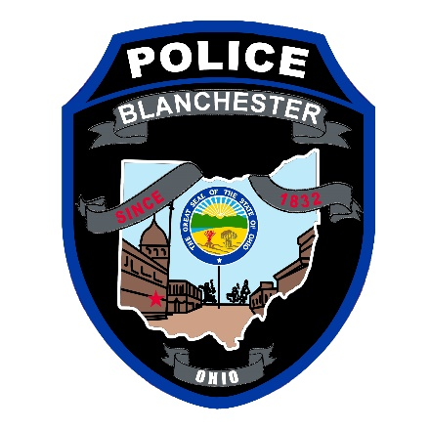
Blanchester Police Department
“The mission of the Blanchester Police Department is to be the Guardians of life, property and the constitutional rights of all our neighbors to ensure a safe and secure community”

POLICE OFFICER JOB DISCRIPTION

General Position Summary
Position: Full Time. The Patrol Officers Position is a commissioned position within the Blanchester Police Department. Benefits include- available health insurance, retirement, overtime opportunities, vacation, compensatory time, shift differential, and personal time. This an hourly position: Starting pay and raises are based on a previously set pay scale.
The Patrol Officer’s responsibilities include enforcing the laws. Ensuring public safety and security of the citizens and property within the Village. Responding to calls of various natures (non-emergency and emergency). Preventing crime by patrolling, regulating traffic, conducting investigations and charging or arresting violators and offenders. Provide a community oriented focus on policing while performing the officer’s daily duties.
Requirements
- High School Diploma.
- Must be 21 years of age at time of appointment.
- Possess a valid Drivers License with satisfactory record.
- No criminal history. (felonies & serious misdemeanors)
- Successful completion of the Ohio Basic Peace Officer Certification.
- Must be able to work various shifts such as day shift, split shift, night shift, weekends, and holidays. At times with little or no notice; shift assignments may be changed at management’s direction.
- Clear radio/ telephone voice and strong communication skills
- Possess the required education level or its equivalent to preform and comprehend the required knowledge, skill and abilities. Ability to obtain and maintain state certification on National Crime Information Center (NCIC), Ohio Law Enforcement Database System (LEADS), OH- Leg and other law enforcement databases.
- Must be able to pass The Ohio Police & Fire pension (OP&F) physical examination – including but not limited to eye, hearing and physical mobility to preform duties as a police officer
- Must submit to a physiological examination
- Must be able to pass The State of Ohio and the Department’s firearms qualifications
- Must pass initial Field Officer’s Training Program and a one-year probationary period

Responsibilities and Duties
- Act in a position of the community trust and service
- Serve and protect citizens along with their property
- Comply with the Department directives, guidelines, policies and procedures
- Patrol Village to deter crime
- Enforce traffic regulations and issue citations
- Check patrol vehicles and all issued equipment to ensure a safe working condition
- Have knowledge of and preform accordingly to current federal, state, and local laws, regulations and ordinances
- Responding promptly to calls of various nature. Non-emergency and emergency, providing emergency aid if needed before EMS or Fire Department arrive on scene
- Respond to domestic disturbances
- Search for missing persons
- Ability to stay calm in stressful or high- risk situations
- Gathering facts during calls so that you may promptly prepare reports
- Investigate crimes, provide scene security, collect evidence, and statements.
- Physically detain, apprehend, or arrest subject(s)
- Complete necessary steps for investigation on previous calls, as needed
- Create a good relationship with the citizens of the community and with fellow employees
- Give accurate information to citizens, pedestrians and motorist
- Ability to demonstrate conflict resolution
- Good decision-making skills
- Complete appropriate paperwork, records, logs, forms, and citations
- Be alert for violations of law, and wanted persons.
- Transport prisoners
- Serve subpoenas, citations, arrest and search warrants.
- Testifying in court and be able to give informed and professional testimony
- Willingness to take extra responsibilities when given assignments
- Attend and successful pass any trainings in person or webinars when required
NOTE: This is only some examples of the police officer’s responsibilities and duties, this not a complete detailed list of all that will be required for the position.

