2025 Blanchester Police Department Year in Review
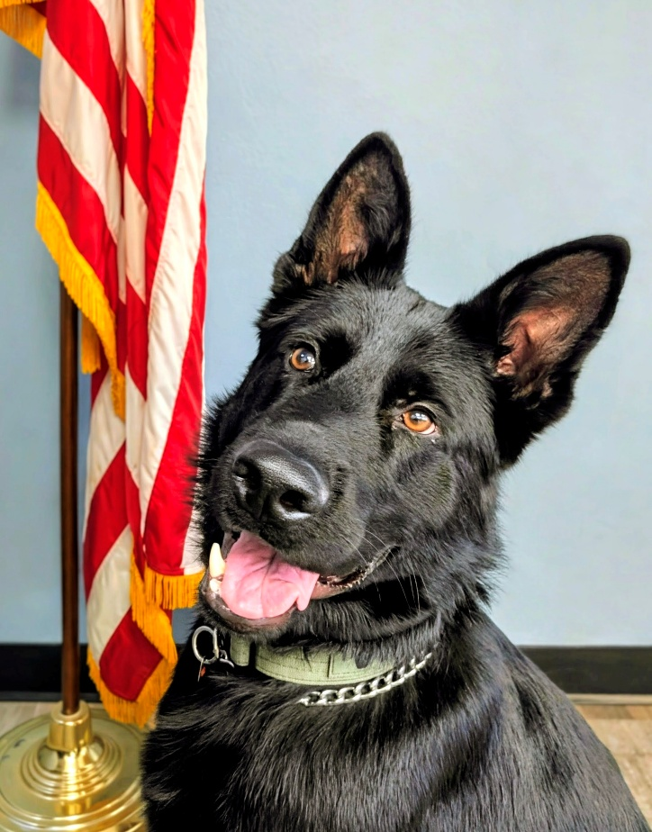
K9 VIDO

Chief Robert J. Houghton
The Blanchester Police Department continued on its mission of serving the people of Blanchester and to be the “Guardians of life, property and the Constitutional Rights of all of our neighbors to ensure a safe and secure community.” One huge step forward in our mission was securing police K-9 “VIDO”! He is a black German Shephard that came from Europe and was trained by Dave Johnson at the Southern Ohio Police K9 Training Institute. A selection process was conducted and Sgt. Jon Petrey was chosen to be Vido’s handler and partner. Together they trained for 5 weeks and were state certified in tracking, apprehension, bite work and detection of illegal narcotics. The Matt Haverkamp Foundation donated the funds necessary to purchase Vido and paid for the training. We also had the Eagles contribute to half the cost of a new police car for Vido. Seven Hills Pet Clinic will be caring for Vido and it has been great seeing the community respond so positively to our K-9 program.
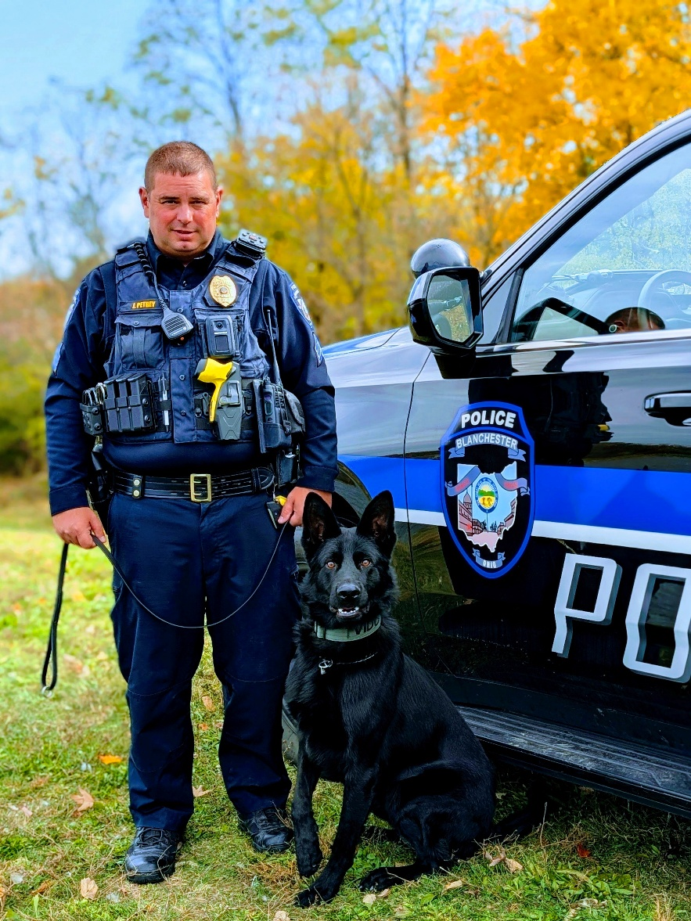
Sgt. Jon Petrey and K9 partner Vido
The K-9 program is an extension of our commitment to the citizens of Blanchester to keep them safe.
Crime:
Crime is lower today than four years ago when we began rebuilding this department. This is largely due to our officers proactively working their shifts, making contact, and keeping an eye over the village in its entirety. Because of officer interaction with the public and high visibility, our total yearly calls of just over 2,000 calls involved fewer felonies. Here is a sampling of what BPD handled in 2025:
CALL LOGS INCIDENTS
Abandoned/Disabled Vehicles-9 Arrests Made-104
Animal Complaints/Kill-88 Crash Reports-55
Civil Problems-53 Assist LE/Fire/EMS-497
Complaints-74 Death Investigations-13
Domestic Complaint/Disputes-39 Theft/Fraud-34
Alarm Drops-66 Domestic Violence-11
Narcotics/Alcohol-26 Breaking and Entering-7
Found Property-25 Burglaries-2
Neighbor Complaints-18 Warrants-48
Vehicle Lock Outs-55 Narcotics-19
Loud Noise Complaints-36 Property Damage/Vandalism-19
Open Doors-30 Arson-1
Investigate Complaints-27 Child Endangering-1
Warrants-15 Sex Offense-7
Welfare Checks-113 Disorderly-7
Mental Health-7
Keeping logs of our officer activities, we are able to track security checks performed and miles patrolled within the village. Having proactive officers means an engaged police department that has had an impact on certain aspects of crime. We all recall the number of individuals wandering the streets in 2022 when the department was at its lowest in terms of staffing and engagement. UCR Data was at its highest. The following chart is interesting in that I believe it shows that our work is and continues to pay off.
5 YEAR HISTORY OF UCR DATA- CRIME
2021 2022 2023 2024 2025
Criminal Homicide | 0 | 0 | 0 | 0 | 0
Forcible Rape | 0 | 4 | 2 | 2 | 4
Robbery | 0 | 0 | 1 | 0 | 0
Aggravated Assault | 8 | 13 | 6 | 8 | 3
Burglary | 10 | 13 | 9 | 8 | 4
Larceny (except motor vehicle theft) | 95 | 124 | 92 | 36 | 19
Motor Vehicle Theft | 4 | 6 | 0 | 3 | 3
Total | 117 | 160 | 110 | 57 | 33

Crime is at its lowest in years in Blanchester, but this does not mean that you need less officers; it means we have the right number of officers to impact crime and to make a difference, while also focusing on community. Blanchester Police officers were involved in 5 vehicle pursuits in 2025 and 4 Use of Force incidents where, thankfully, no one was injured and all suspects were appropriately charged and sentenced.
Clinton County Sheriff’s Office, Blanchester Police Department, Sabina Police Department and Wilmington Police Department all worked cooperatively together in a drug investigation named “Operation Kickstart” that reached some 52 people that were illegally using and selling in our county. The resulting investigation resulted in 732 count indictments on drug charges, 11 of those people were indicted for drug trafficking in Blanchester. The spirit of cooperation among law enforcement has never been better.
As a result of ongoing investigations and hard work several sentencings happened over the course of the year through the Courts of Common Pleas. The following list does not include misdemeanor crimes that were sentenced in Clinton County Municipal Court.

2025 Sentences
*Operation Kickstart- James Travis Newland: Reports 24-249 and 24-269: Trafficking in Fentanyl-Related Compound (indicted on 2, pled to one count, with the 2nd dismissed): 12-month prison term concurrent with other case.
25-070: Indicted on attempted burglary, and pled/found guilty of same. 2-year prison term concurrent with above drug case.
*Operation Kickstart- Jaden Johnson: Reports 25-011 & 012: Pled guilty to, and found guilty, of Aggravated Trafficking of Drugs, F4/ 2 years of community control.
*Operation Kickstart-Paul Bailey Jr: Report 24-050: Aggravated Possession of Drugs- Pled guilty to one count of aggravated possession of drugs/2 years community control/treatment
*Operation Kickstart- Trina Penny: Report 24-050, Aggravated Possession of Drugs/2 years of community control and 6-month jail term
Timothy Whitworth- indicted on felonious assault that occurred in April 2025, charge amended to aggravated assault (F4). 2 years of community control, 6 month suspended jail term.
Harold Payne-indicted on several felonies stemming from the stabbing in the spring of 2025. Pled Guilty to felonious assault (F2) and tampering with evidence (F3). Sentenced to no less than 4, no more than 6 years in prison.
Marissa Johnson (Ohio Fire Marshal Case)- Indicted on several counts of aggravated arson stemming from the fire in April 2025 at Buckeye Self Storage. Pled to one count of aggravated arson (F1), and 10 counts of arson (F4). Sentenced to 7 to 10.5 years in prison.
*Operation Kickstart: Devin Johnson: 24-140: Aggravated Possession of Drugs, F5 2 years of community control and treatment
September 2022 Break In @ 203 E. Main Street Break-In (22-384): Jaden Johnson pled to Breaking & Entering, 2 years of community control. Arnold J. Smith Jr., 2 years community control for Receiving Stolen Property. Devin Johnson pled to Breaking & Entering and was sentenced to 2 years of community control and residential treatment. In 2024, Denver Melampy pled to/found guilty of Receiving Stolen Property and Breaking & Entering, and sentenced to 9 months in prison for this same case.
Arnold J. Smith Jr: 2 years community control for breaking and entering into campers at Michael’s Storage in February 2023.
Arnold J. Smith Jr.: Report 22-476, 2 years community control for vandalism for the break-in at Tom’s Express Mart in December 2022.
Donald Morgan sentenced to 12 months of prison for a November 2025 Failure to Comply.
Devin Johnson, 25-116, 18-month prison term for tampering with evidence. 24-140, 2 years of community control for aggravated possession of drugs x 2 stemming from a May 2024 incident and a December 2023 incident.
Mark Paul, 24-124, sentenced to 2 years of community control for aggravated possession of drugs, stemming from a May 2024 incident.
Robert Hartmier, 22-476, sentenced to 9 months of prison for a Breaking and Entering conviction stemming from the December 2022 break-in at Tom’s Express Mart.
*Operation Kickstart- Casey Gillis, 24-133 and 250: Pled guilty to 2 counts of Aggravated trafficking in Drugs and two counts Aggravated Possession of Drugs, and sentenced to 18 months in prison.
Brian Mountjoy, sentenced to 24 months in prison for Assault on a Police Officer and Failure to Comply with the signal of a Police Officer, stemming from a pursuit in January 2025.
Logan Allen sentenced to 2 years of community control for aggravated possession of drugs, stemming from a May 2024 incident.
Mark Cope, sentenced to 2 years of community control for aggravated possession of drugs from a September 2023 incident.
Shaun Larkin, sentenced to 48 months in prison for failing to comply with the signal of a police officer, from a pursuit that occurred in November 2024.

Community Events:

Thanks to great support from our community, we have been able to take time to interact with our neighbors by doing events such as Cops and Bobbers, Cones with Cops, Click it for Coney’s, and National Night Out Against Crime. We were also able to help others by giving back through the Glenn Thompson Memorial Food Drive and Shop with a Cop. Officers have been able to get closer with those they serve and setting an example to our youth by giving them positive role models to look up to. Blanchester is truly blessed to have so many that come together and work together to make our events and other events, such as the Parks Department’s, a huge success.
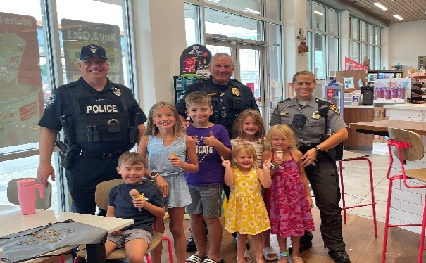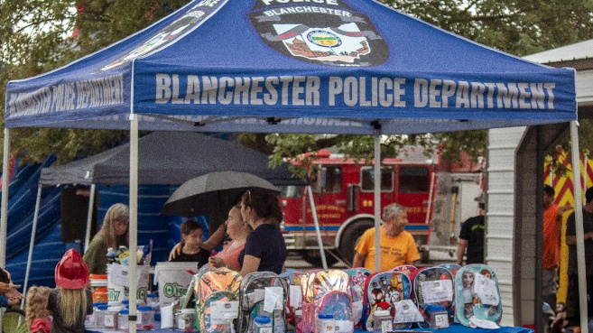
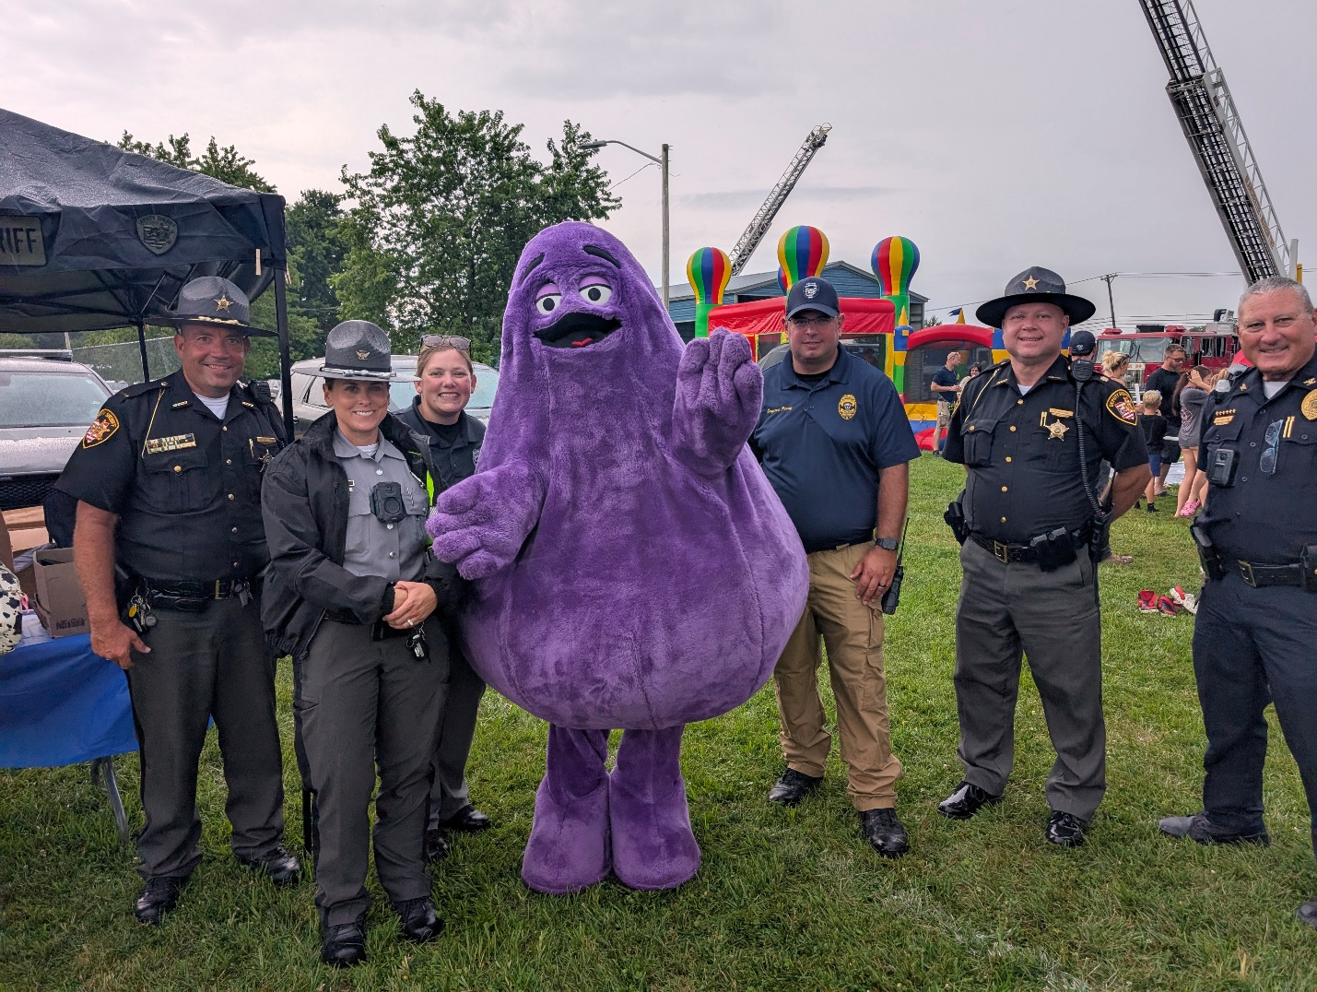
Throughout our community engagement, we have also been supported by all members of other Clinton County Law Enforcement. Wilmington PD, Sabina PD, Ohio State Highway Patrol, and Clinton County Sheriff’s Office have been there to support us with our community events and crime fighting.
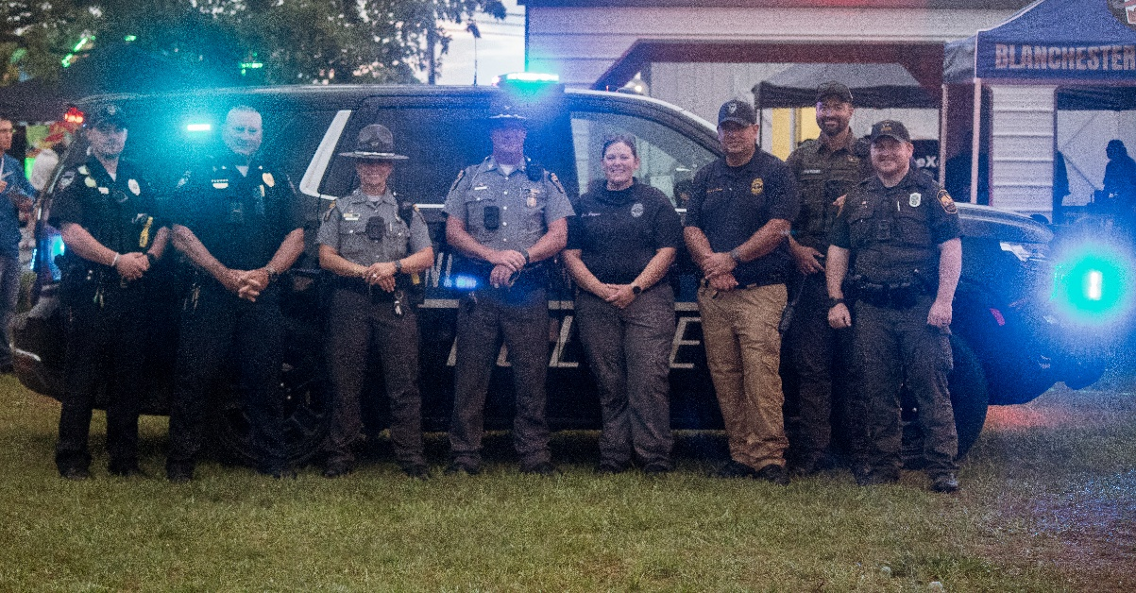
One of our largest sponsors this past year has been the Blanchester Eagles. Not only in supporting our K-9 Program, but also in generously donating to help us put together the best fireworks display in Clinton County for National Night Out! Great things happen when the police and the community work together.
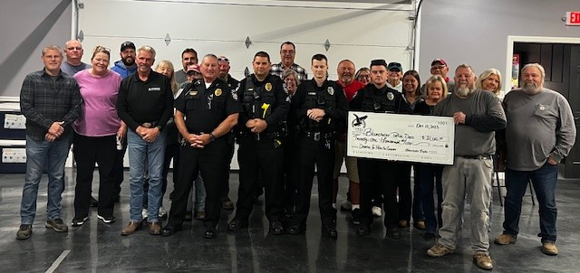
One of the most rewarding aspects that I have heard described by officers was the Shop with a Cop program, which was brought back to Clinton County in 2024. This program expanded in 2025, and there are even more plans to build this program even more in 2026. Shop with a Cop is a program where officers from all departments come together and bring some of our young people shopping. This program is made possible with the support of law enforcement within the county and Wal-Mart, and is funded by fundraising. This year, we helped raise funds by having a competitive bowling tournament. I cannot lie; Chief “Twinkle Toes Flintstone” Houghton rolled his share of gutter balls, failing to bring the trophy home to Blanchester. Later this year, we will be recruiting.
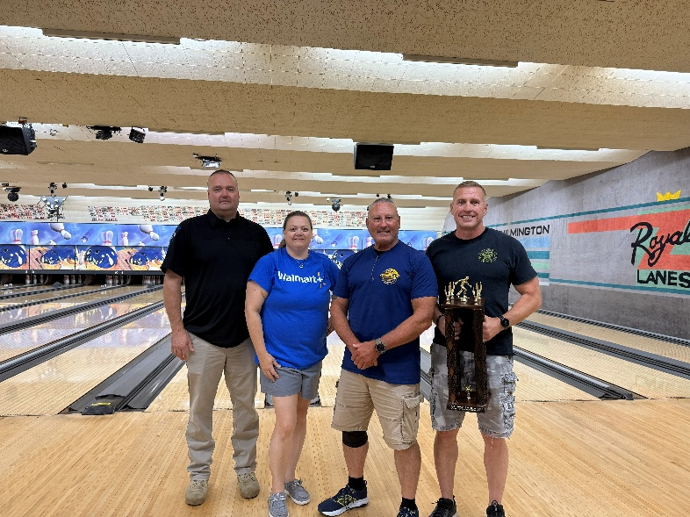
There has been a lot of great support, and when you have support from literally every aspect, you cannot fail. During our National Night Out, we had a dunking booth, funded by Allstate. Donations were accepted, which went towards our community events to keep things moving forward. Even our mayor was involved getting dunked, along with our Streets Supervisor, Paul:
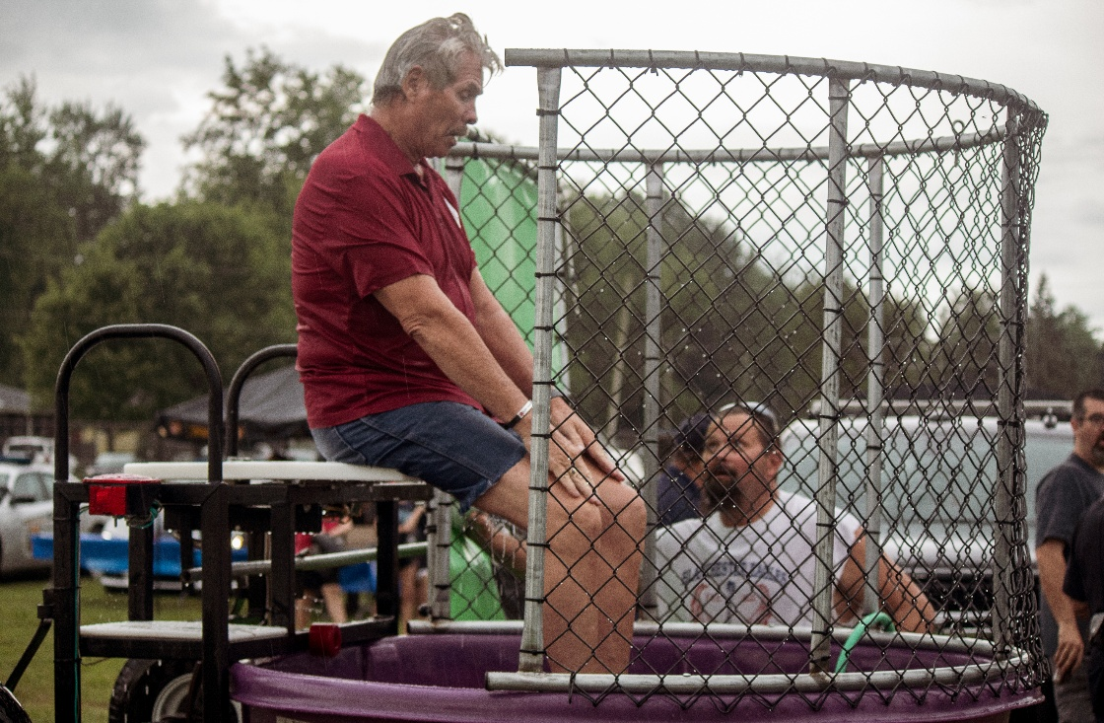

Training:
One of the ways for us to be successful as a police department is for the continued training of our officers. The State of Ohio requires 24 hours of CPT (Continuing Professional Training) every year and they, of course, choose the topics of the training. All of our officers complete that training, but we also send them for additional training. We recognize that every officer wishes to professionally develop themselves as their careers advance. Lending to their education gives us better prepared officers who are also well-rounded and ready.
Some of the areas we focused on this year is PIT (Pursuit Termination Techniques), Evidence Technician, Field Training Officer, Investigation of Child Homicide and Unexplained Deaths, Drone Legal Updates, and myself and Sergeant Petrey attended the Chief’s Conference in Columbus, which had several learning topics. Officers attended ARIDE (Advanced Roadside Impaired Driving Enforcement) and honed their skill at detecting drug and alcohol OVI’s.

Equipment:
A grant was secured from the Vallee Fund for a drone and the addition of 4 speed safety signs in town. These were placed in some of the more commonly complained on areas and have had some success. We recently applied for another grant to add more signs, and were just notified that we will be awarded funds to add two more signs this spring. The drone is American made, and will be staffed by two officers who are currently working on training to get certified to be pilots. There was a lengthy wait for the drone to ship, however, we received the drone on January 23rd and look forward to getting the drone program up and running. The drone will increase our capabilities and become a force multiplier in times of crisis. There will be a drone program throughout the county where training and collaboration will take place with all agencies. Look for the new drone to be out during our National Night Out.

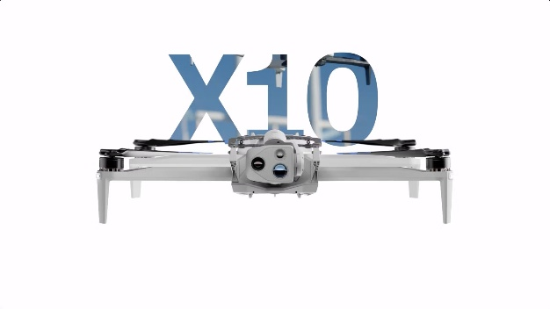

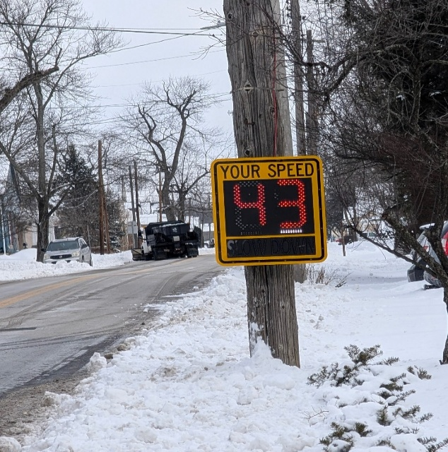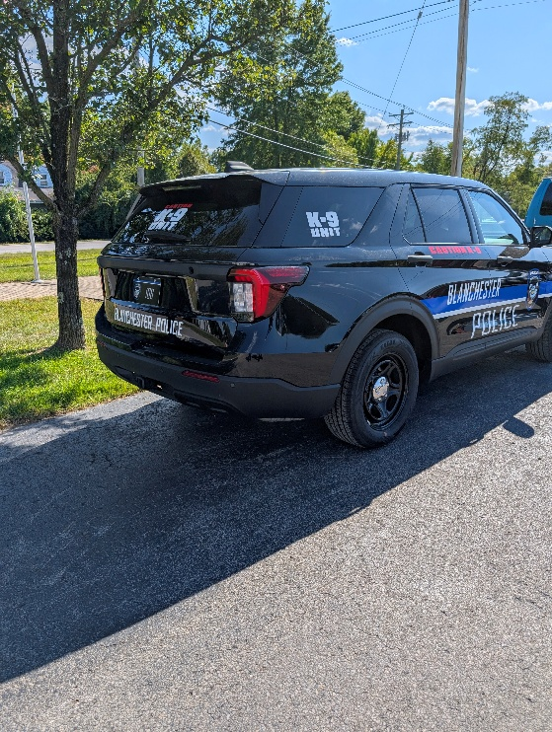
As previously mentioned, the K-9 program is up and running and the cruiser, K-9, and equipment purchased is all new and made possible by local donations and grants.
Flock cameras were installed and have been used successfully to apprehend and identify criminal suspects. Thanks to Flock 186 grams of methamphetamine were taken off the street following a short pursuit, after the truck was identified as being driven by a wanted subject, indicted for drugs in 3 counties. The driver of a stolen motorcycle that fled from police in a pursuit, before the officer terminated the pursuit for safety concerns, was identified when his image was captured by the PTZ cameras downtown. These are just a couple of incidents where Flock has shown to be a tremendous asset to our department.
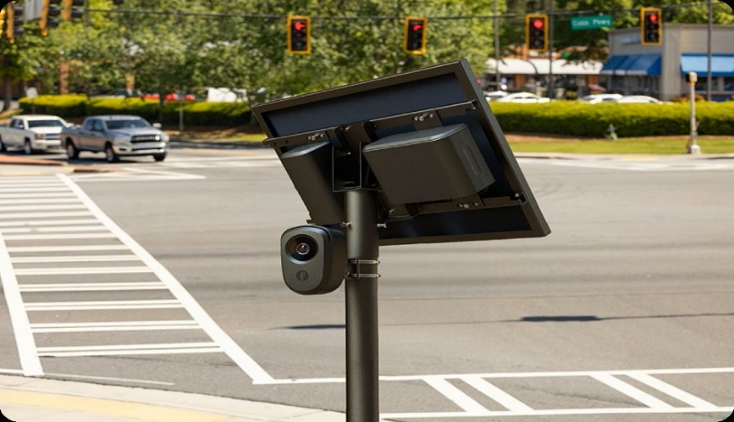
One of the biggest investments of 2025 were the body worn cameras. Our Motorola cameras were purchased with a grant from the State of Ohio. Officers were trained, equipped and policy written that governed the employment of these cameras. The officers have really taken to the new technology as they find evidence documentation and recording of facts very helpful. This was very widely accepted and supported by the community who wanted the transparency.
Officer of The Year:
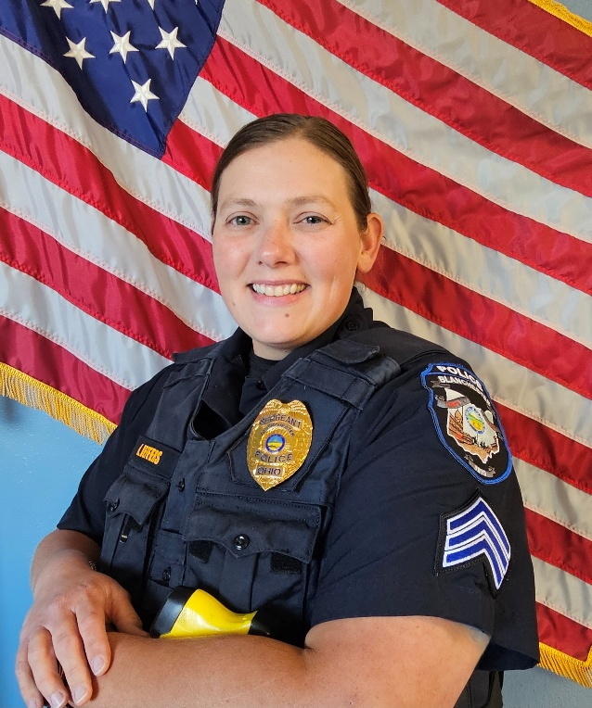
Det. Sgt. Kristen Jeffers
Once again, the officers voted on who they felt deserved the honor of being this year’s Officer of the Year. The 2025 Officer of the Year is Det. Sgt. Kristen Jeffers; she definitely deserves it. Kristen is always busy working at so many things and keeping the police department running. She is involved in criminal investigations, road patrol, supervisory duties, social media posts, community events organizer and planner, you name it she is the go-to person at this department. She is an example to our younger officers.

In conclusion, 2025 was a great year for our police department. It was our first year in a very long time in which we had stability. We experienced no employee turnover and we thank the mayor and council for supporting the police. The way that the village supports its police is evident in the programs that have been passed and the wages that have been improved upon. We thank all of the people of Blanchester for their continued support and look forward to serving you even better in 2026!

